Supplementary Figure 1: HOPE treated DCD livers were matches 1:2 with un-perfused DCD livers and DBD livers in terms of donor asystolic warm ischemia (A) and recipient BAR score (B).

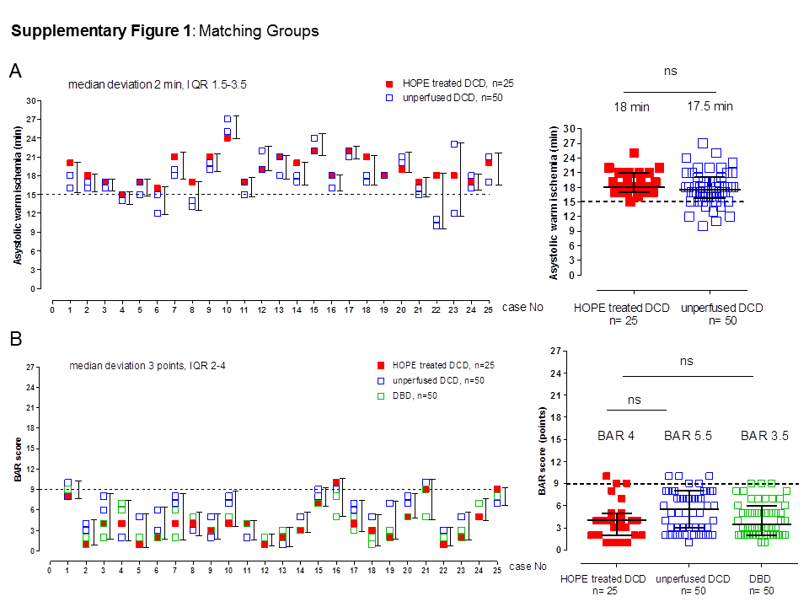

Supplementary Figure 2: In the groups of un-perfused DCD livers, eight patients developed multifocal ischemic cholangiopathy with the need to retransplantion in 6 of 8 cases within 5.1 months (median).
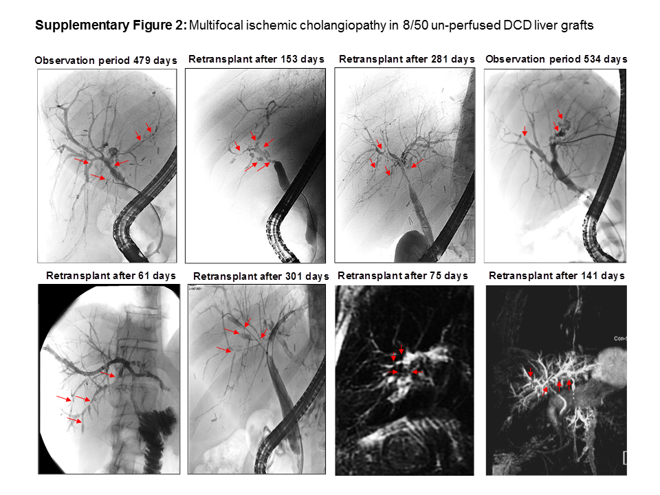

Supplementary Table 1: Matching Groups

Match No | Study Group | BAR | Asystolic WI (min) | Match No | Study Group | BAR | Asystolic WI (min) | Match No | Study Group | BAR | Asystolic WI (min)
1 | HOPE treated DCD | 8 | 20 | 10 | HOPE treated DCD | 4 | 24 | 18 | HOPE treated DCD | 3 | 21
1 | unperfused DCD | 8 | 18 | 10 | unperfused DCD | 8 | 27 | 18 | unperfused DCD | 2 | 18
1 | unperfused DCD | 10 | 16 | 10 | unperfused DCD | 7 | 25 | 18 | unperfused DCD | 5 | 17
1 | DBD | 9 |  | 10 | DBD | 5 |  | 18 | DBD | 2
1 | DBD | 9 |  | 10 | DBD | 5 |  | 18 | DBD | 1
2 | HOPE treated DCD | 1 | 18 | 11 | HOPE treated DCD | 4 | 17 | 19 | HOPE treated DCD | 2 | 18
2 | unperfused DCD | 4 | 16 | 11 | unperfused DCD | 2 | 15 | 19 | unperfused DCD | 3 | 18
2 | unperfused DCD | 3 | 17 | 11 | unperfused DCD | 4 | 17 | 19 | unperfused DCD | 7 | 18
2 | DBD | 1 |  | 11 | DBD | 4 |  | 19 | DBD | 2
2 | DBD | 2 |  | 11 | DBD | 4 |  | 19 | DBD | 3
3 | HOPE treated DCD | 4 | 17 | 12 | HOPE treated DCD | 1 | 19 | 20 | HOPE treated DCD | 5 | 19
3 | unperfused DCD | 6 | 17 | 12 | unperfused DCD | 2 | 19 | 20 | unperfused DCD | 7 | 21
3 | unperfused DCD | 8 | 16 | 12 | unperfused DCD | 2 | 22 | 20 | unperfused DCD | 8 | 20
3 | DBD | 4 |  | 12 | DBD | 2 |  | 20 | DBD | 5
3 | DBD | 2 |  | 12 | DBD | 2 |  | 20 | DBD | 5
4 | HOPE treated DCD | 4 | 15 | 13 | HOPE treated DCD | 2 | 21 | 21 | HOPE treated DCD | 9 | 17
4 | unperfused DCD | 7 | 15 | 13 | unperfused DCD | 1 | 18 | 21 | unperfused DCD | 10 | 15
4 | unperfused DCD | 2 | 14 | 13 | unperfused DCD | 2 | 21 | 21 | unperfused DCD | 10 | 16
4 | DBD | 6 |  | 13 | DBD | 2 |  | 21 | DBD | 5
4 | DBD | 7 |  | 13 | DBD | 3 |  | 21 | DBD | 9
5 | HOPE treated DCD | 1 | 17 | 14 | HOPE treated DCD | 3 | 20 | 22 | HOPE treated DCD | 1 | 18
5 | unperfused DCD | 2 | 15 | 14 | unperfused DCD | 5 | 18 | 22 | unperfused DCD | 2 | 11
5 | unperfused DCD | 5 | 17 | 14 | unperfused DCD | 3 | 17 | 22 | unperfused DCD | 3 | 10
5 | DBD | 2 |  | 14 | DBD | 3 |  | 22 | DBD | 2
5 | DBD | 2 |  | 14 | DBD | 3 |  | 22 | DBD | 2
6 | HOPE treated DCD | 2 | 16 | 15 | HOPE treated DCD | 7 | 22 | 23 | HOPE treated DCD | 2 | 18
6 | unperfused DCD | 3 | 12 | 15 | unperfused DCD | 9 | 22 | 23 | unperfused DCD | 2 | 12
6 | unperfused DCD | 6 | 15 | 15 | unperfused DCD | 8 | 24 | 23 | unperfused DCD | 5 | 23
6 | DBD | 2 |  | 15 | DBD | 7 |  | 23 | DBD | 2
6 | DBD | 2 |  | 15 | DBD | 7 |  | 23 | DBD | 3
7 | HOPE treated DCD | 4 | 21 | 16 | HOPE treated DCD | 10 | 18 | 24 | HOPE treated DCD | 5 | 17
7 | unperfused DCD | 7 | 18 | 16 | unperfused DCD | 9 | 16 | 24 | unperfused DCD | 7 | 18
7 | unperfused DCD | 8 | 19 | 16 | unperfused DCD | 8 | 18 | 24 | unperfused DCD | 7 | 16
7 | DBD | 6 |  | 16 | DBD | 5 |  | 24 | DBD | 7
7 | DBD | 2 |  | 16 | DBD | 8 |  | 24 | DBD | 7
8 | HOPE treated DCD | 4 | 17 | 17 | HOPE treated DCD | 4 | 22 | 25 | HOPE treated DCD | 9 | 20
8 | unperfused DCD | 3 | 13 | 17 | unperfused DCD | 6 | 22 | 25 | unperfused DCD | 7 | 17
8 | unperfused DCD | 3 | 14 | 17 | unperfused DCD | 7 | 21 | 25 | unperfused DCD | 8 | 21
8 | DBD | 5 |  | 17 | DBD | 3 |  | 25 | DBD | 8
8 | DBD | 5 |  | 17 | DBD | 5 |  | 25 | DBD | 8
9 | HOPE treated DCD | 3 | 21
9 | unperfused DCD | 2 | 20
9 | unperfused DCD | 5 | 19
9 | DBD | 3
9 | DBD | 3

